**AUTOMATIC FACE MASK AND TEMPERATURE DETECTION CONTROL SYSTEM**

by

J Kiron 18BEC1150

P Illavenil 17BEC1046

S Ramnath 17BEC1107

A project report submitted to

**Dr. M. JAGANNATH**

**SCHOOL OF ELECTRONICS ENGINEERING**

in partial fulfilment of the requirements for the course of

**ECE2010 - CONTROL SYSTEMS**

in

**B.Tech. ELECTRONICS AND COMMUNICATION ENGINEERING**



**VELLORE INSTITUTE OF TECHNOLOGY, CHENNAI**

**Vandalur – Kelambakkam Road**

**Chennai – 600127**

**NOVEMBER 2020**

**BONAFIDE CERTIFICATE**

Certified that this project report entitled “**Face mask and temperature detection”** is a bonafide work of**, J KIRON (18BEC1150**), **P Illavenil (17BEC1046)** and **S Ramnath (17BEC1107)** who carried out the Project work under my supervision and guidance for ECE3003: Microcontrollers and its applications.

**Dr. M. JAGANNATH**

Associate Professor

School of Electronics Engineering (SENSE),

Vellore Institute of Technology, Chennai– 600 127.

**ABSTRACT**

This pandemic has pushed us to a situation where we have to take extreme precautionary measures to take care of ourselves and our loved ones. To not spread the disease/get contacted by it, it is advised to wear a face mask outdoors. It would be a lot easier in public places if there was an automatic system that would check people for face masks and body temperature. The Proposed Covid prevention method scans the face for face masks and their body temperature. We have built a CNN model that detects the presence of face masks in people from a webcam using Keras running in a TensorFlow background, OpenCV, and MobileNet V2 architecture. We have used MLX90614ESF Contactless Temperature Sensor to measure the body temperature at the entrance. The MLX90614ESF is connected to the Arduino and temperature is displayed in a 16*2 LCD display. A binary digit is sent to the Arduino via serial port using the package pyserial.‘0’ indicates that the person is not wearing a mask and binary digit ‘1’ indicates he is wearing a mask. Upon inspection, if both conditions are satisfied (face mask: ON, Body Temperature < 100.4°C), the control system would open the gates, allowing the person to enter. We have used a servo motor which acts as a gate. The servo motor rotates by an angle of 90 degrees and then goes back to the original state. This method helps in the prevention of COVID19 to a great extent as wearing a mask and checking temperature constantly is mandatory.

**ACKNOWLEDGEMENT**

We wish to express our sincere thanks and deep sense of gratitude to our project guide, **Dr. M Jagannath,** Associate Professor, School of Electronics Engineering, for her consistent encouragement and valuable guidance offered to us in a pleasant manner throughout the course of the project work.

We are extremely grateful to**, Dr. Sivasubramanian. A** Dean of the School of Electronics Engineering, Vellore Institute of Technology, Chennai, for extending the facilities of the School towards our project and for her unstinting support.

We express our thanks to our Head of the Department **Dr. Vetrivelan. P** for his support throughout the course of this project. We also take this opportunity to thank all the faculty of the School for their support and their wisdom imparted to us throughout the course.

We thank our parents, family, and friends for bearing with us throughout the course of our project and for the opportunity they provided us in undergoing this course in such a prestigious institution.

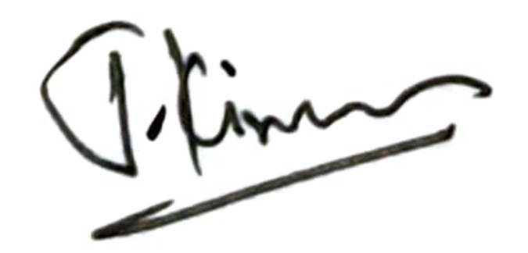 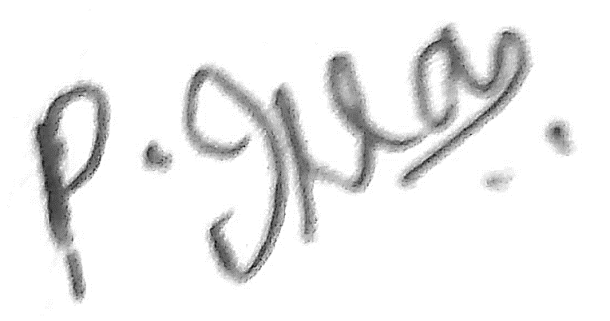 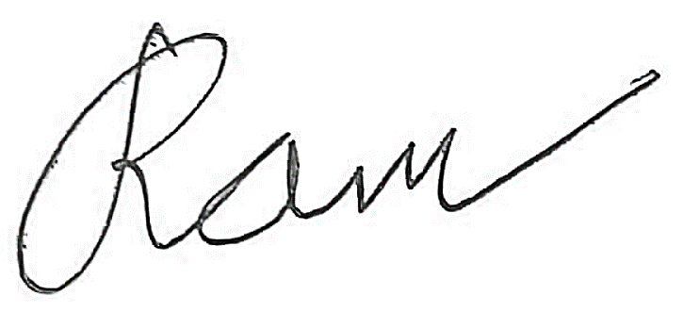

**J KIRON P ILLAVENIL S RAMNATH**

**TABLE OF CONTENTS**

|  |  |  |  |
| --- | --- | --- | --- |
| **SERIAL NO.** |  | **NAME** | **PAGE NO.** |
|  |  | **ABSTRACT** | **3** |
|  |  | **ACKNOWLEDGEMENT** | **4** |
|  |  |  |  |
| **1** |  | **INTRODUCTION** | **6** |
|  |  |  |  |
|  | **1.1** | **OBJECTIVES AND GOALS** | **6** |
|  | **1.2** | **BENEFITS** | **6** |
|  | **1.3** | **FEATURES** | **6** |
|  |  |  |  |
| **2** |  | **DESIGN** | **7-11** |
|  | **2.1**  **2.2** | **BLOCK DIAGRAM**  **CIRCUIT DIAGRAM** | **7**  **8** |
|  | **2.3**  **2.4**  **2.5** | **TRANSFER FUNCTION**  **HARDWARE ANALYSIS**  **SOFTWARE ANALYSIS** | **8-9**  **10-16**  **16** |
|  |  |  |  |
| **3** | **3.1**  **3.2**  **3.3**  **3.4** | **SOFTWARE IMPLEMENTATION**  **SOFTWARE CODING**  **WORKING**  **SIMULATION**  **EXPERIMENTAL RESULTS AND IMAGES** | **17-17**  **17**  **21**  **22**  **23** |
|  |  |  |  |
| **4** |  | **CONCLUSION AND FUTURE WORK** | **24** |
|  | **4.1** | **RESULT, CONCLUSION AND INTERFERANCE** | **24** |
|  | **4.2** | **FUTURE WORK** | **24** |

**REFERENCES 25**

**CHAPTER 1**

**INTRODUCTION**

**1.1 OBJECTIVES AND GOALS**

Our goal is to design a Control system:

It monitors whether a person is wearing the mask and his body temperature is less than 100.4F if so the gate opens else the gate remains closed.

**1.2 BENEFITS**

* It is a fully automated system without human interference.
* It is a cost-efficient process

**1.3 FEATURES**

* 16 X 2 LCD Display for user to see the final output
* LED if it glows it means the person is either not wearing a mask or temperature is greater than 100.4
* Servo motor is used as a gate if the temperature is less than 100.4 and wearing a mask then the gate opens.
* Microcontroller used is Arduino.

**CHAPTER 2**

**DESIGN**

**2.1 BLOCK DIAGRAM**

The three main features of the basic block diagram (given below) are

* Contactless Temperature Sensor (MLX90614ESF)
* LCD
* Arduino

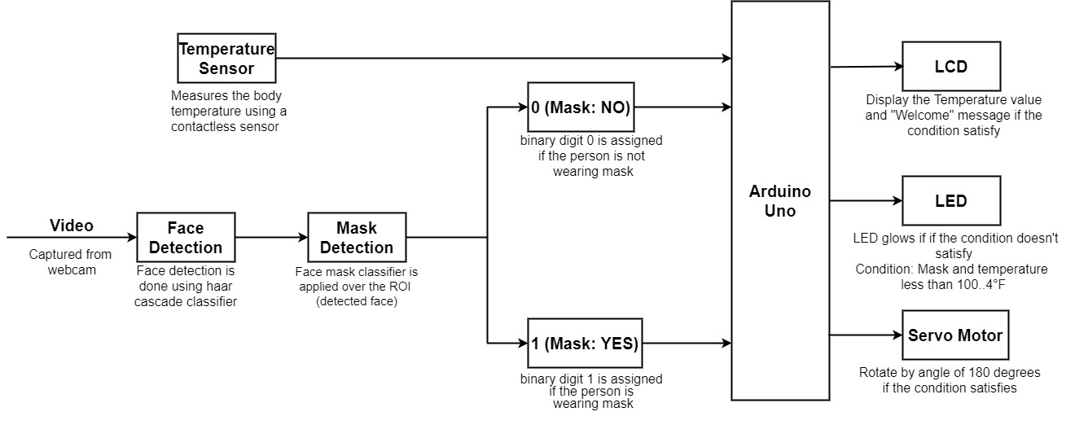Each of the above units may consist of the sensory units, communication modules, etc.

Figure 2.1.1: Block diagram with all the components used

In Figure 2.1.1, Mask detection is performed first using a CNN model[3]. Bit ‘1’ is transmitted to the arduino using pyserial if the person is wearing the mask else bit’0’ is transmitted. The Arduino is connected to the MLX90614 contactless temperature sensor which measures the body temperature. The final output of the temperature is displayed and the gate open if the both conditions satisfy.

**2.2 CIRCUIT DIAGRAM**

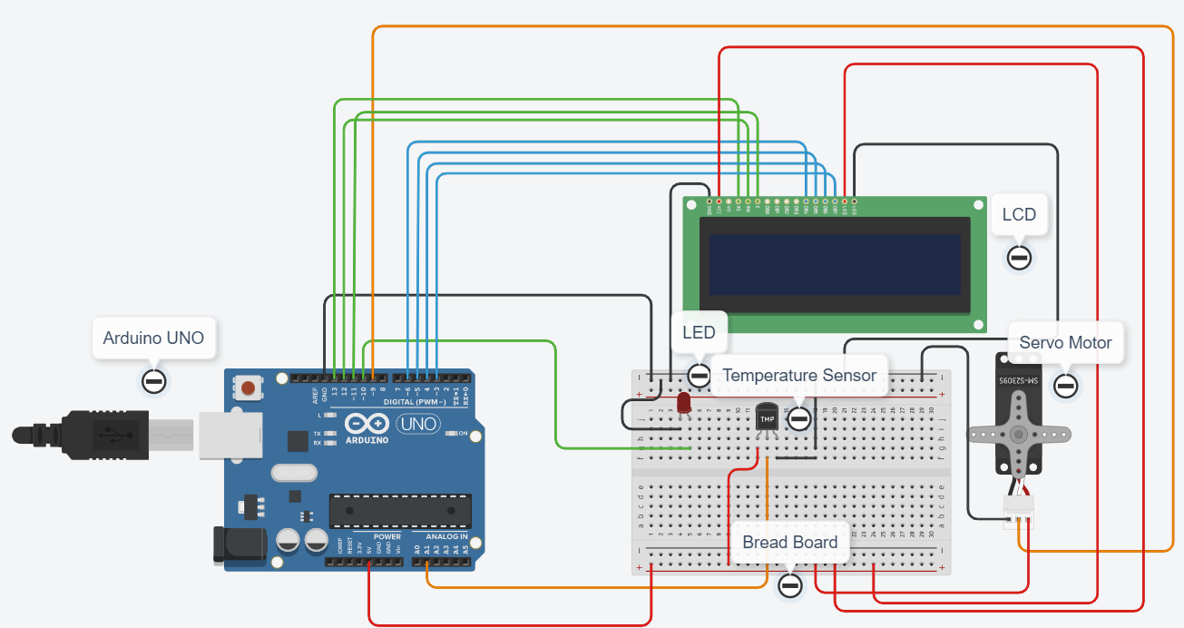

Figure 2.2.1: Circuit Diagram of Automatic Face Mask and Temperature Detection Control System

The specifications of the hardware in the Figure 2.2.1 which shows the circuit diagram has been discussed in the Hardware analysis section of the report.

**2.3 POSSIBLE TRANSFER FUNCTION**

* **POSSIBLE TRANSFER FUNCTION OF AN ON/OFF CONTROLLER**

For an ON/OFF controller system, the only parameter by which the transfer function depends is the ON/OFF state of the system. So, when the system outputs ON, an impulse response occurs at that moment. If the system outputs OFF, the output is a simple 0 (zero). Therefore, the transfer function of an ON/OFF controller is the laplace transform of impulse response.

$$G_{1}\left(s\right)=e^{-τs}$$

Considering time delay τ =2 seconds until a new face is processed,

$$G_{1}\left(s\right)=e^{-2s}$$

* **POSSIBLE TRANSFER FUNCTION OF THE TEMPERATURE SENSOR LM35.**

From the datasheet of LM35 temperature sensor, its transfer function was found.

$$G_{2}\left(s\right)=\left(10\frac{mV}{℃}\right)= \frac{10}{1.8+32}\frac{mV}{℉}=0.296\frac{mV}{℉}$$

* **THE TOTAL TRANSFER FUNCTION OF THE SYSTEM**

$$G\left(s\right)=G_{1}\left(s\right)×G_{2}\left(s\right)$$

$$G\left(s\right)=0.296e^{-2s}$$

**POSSIBLE TRANSFER FUNCTION OF THE SYSTEM**

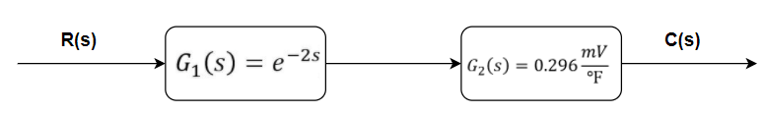

**Figure 2.3.1 Block diagram of the system**

Figure 2.3.1 shows the block diagram of the system. Figure 2.3.2 and Figure 2.3.3 shows the intermediate step to reduce the block diagram and the reduced block diagram respectively.

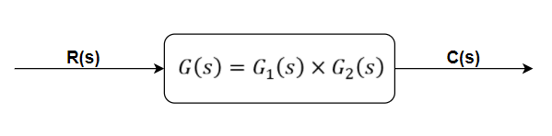

**Figure 2.3.2 Intermediate step to reduce block diagram**

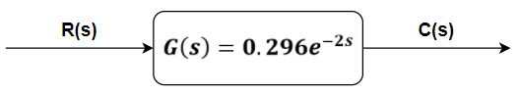

**Figure 2.3.3 Reduced block diagram**

**2.4 HARDWARE ANALYSIS**

The face mask detection and temperature detection consist of the following components which are described below.

* Arduino UNO
* LCD
* LED
* Contactless Temperature Sensor (MLX90614ESF)
* Servo motor

**2.4.1 LCD:**

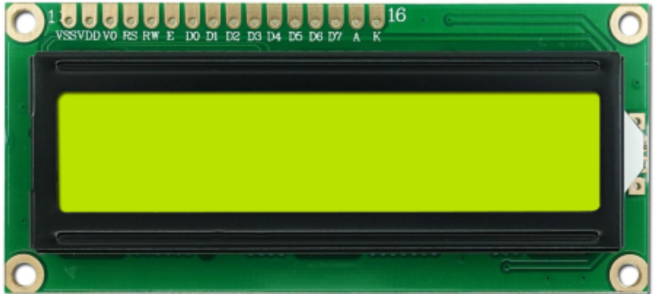

Figure 2.4.1 LCD component

An LCD as shown in Figure 2.4.1, is an electronic display module which uses liquid crystal to produce a visible image. The 16×2 LCD display is a very basic module commonly used in [DIYs](https://electronicsforu.com/category/electronics-projects/hardware-diy) and circuits. The 16×2 translation displays 16 characters per line in 2 such lines[2]. In this LCD each character is displayed in a 5×8 pixel matrix. The pin configuration of LCD is mentioned in Table 1.

### **Features of 16×2 LCD module**

* Operating Voltage is 4.7V to 5.3V
* Current consumption is 1mA without backlight
* Alphanumeric LCD display module, meaning can display alphabets and numbers
* Consists of two rows and each row can print 16 characters.
* Each character is built by a 5×8-pixel box
* Can work on both 8-bit and 4-bit mode
* It can also display any custom generated characters
* Available in Green and Blue Backlight

**Pin Configuration**

|  |  |  |
| --- | --- | --- |
| **Pin No.** | **Function** | **Name** |
| 1 | Ground (0V) | Ground |
| 2 | Supply voltage; 5V (4.7V – 5.3V) | Vcc |
| 3 | Contrast adjustment; the best way is to use a variable resistor such as a potentiometer. The output of the potentiometer is connected to this pin. Rotate the potentiometer knob forward and backwards to adjust the LCD contrast. | Vo / VEE |
| 4 | Selects command register when low, and data register when high | RS (Register Select ) |
| 5 | Low to write to the register; High to read from the register | Read/write |
| 6 | Sends data to data pins when a high to low pulse is given; Extra voltage push is required to execute the instruction and EN(enable) signal is used for this purpose. Usually, we make it en=0 and when we want to execute the instruction we make it high en=1 for some milliseconds. After this we again make it ground that is, en=0. | Enable |
| 7 | 8-bit data pins | DB0 |
| 8 | DB1 |
| 9 | DB2 |
| 10 | DB3 |
| 11 | DB4 |
| 12 | DB5 |
| 13 | DB6 |
| 14 | DB7 |
| 15 | Backlight VCC (5V) | Led+ |
| 16 | Backlight Ground (0V) | Led- |

Table 1: Pin configuration of LCD

**2.4.2 Arduino**

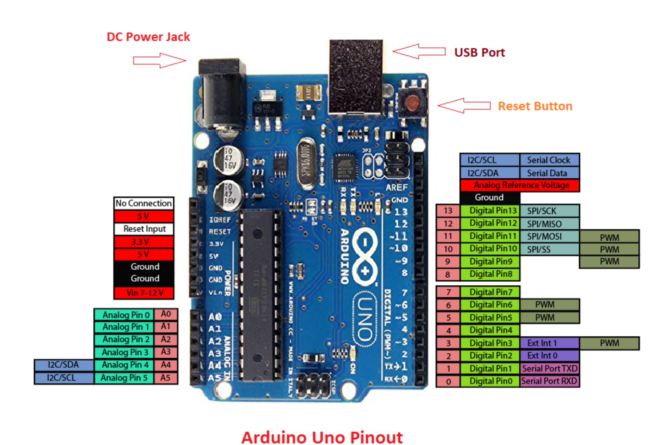Figure 2.4.2: Pin diagram of Arduino UNO

Figure 2.4.2 shows the pin diagram of the 8051 microcontroller that plays a major role in the system. The pin details are also mentioned below.

Arduino is an open-source electronics platform based on easy-to-use hardware and software. [Arduino boards](https://www.arduino.cc/en/Main/Products) are able to read inputs - light on a sensor, a finger on a button, or a Twitter message - and turn it into an output - activating a motor, turning on an LED, publishing something online. You can tell your board what to do by sending a set of instructions to the microcontroller on the board. To do so you use the [Arduino programming language](https://www.arduino.cc/en/Reference/HomePage) (based on [Wiring](http://wiring.org.co/)), and [the Arduino Software (IDE)](https://www.arduino.cc/en/Main/Software), based on [Processing](https://processing.org/).

Over the years Arduino has been the brain of thousands of projects, from everyday objects to complex scientific instruments. A worldwide community of makers - students, hobbyists, artists, programmers, and professionals - has gathered around this open-source platform, their contributions have added up to an incredible amount of [accessible knowledge](http://forum.arduino.cc/) that can be of great help to novices and experts alike.

Arduino was born at the Ivrea Interaction Design Institute as an easy tool for fast prototyping, aimed at students without a background in electronics and programming. As soon as it reached a wider community, the Arduino board started changing to adapt to new needs and challenges, differentiating its offer from simple 8-bit boards to products for IoT applications, wearable, 3D printing, and embedded environments. All Arduino boards are completely open-source, empowering users to build them independently and eventually adapt them to their particular needs. The [software](https://www.arduino.cc/en/Main/Software), too, is open-source, and it is growing through the contributions of users worldwide.

**2.4.3 Contactless Temperature Sensor (MLX90614ESF)**

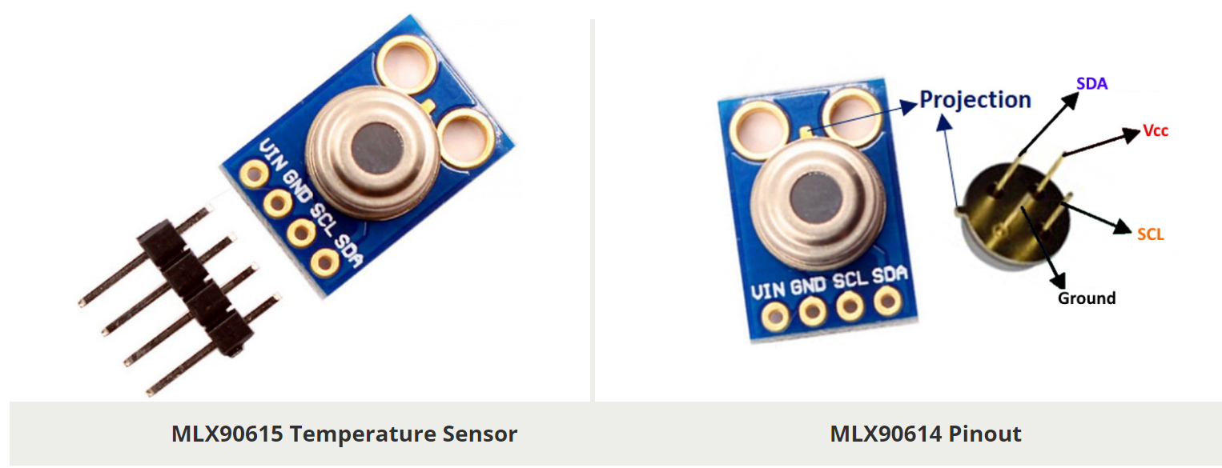

Figure 2.4.3 MLX90615 Contactless IR Digital Temperature Sensor

The MLX90614 is a Contactless Infrared (IR) Digital Temperature Sensor as shown in Figure 2.4.3 that can be used to measure the temperature of a particular object ranging from -70° C to 382.2°C. The sensor uses IR rays to measure the temperature of the object without any physical contact and communicates to the microcontroller using the I2C protocol. The pin configuration of the sensor is shown in Table 2.

### **MLX90614 Pinout Configuration**

|  |  |  |
| --- | --- | --- |
| **Pin No.** | **Pin Name** | **Description** |
| **1** | Vdd (Power supply) | Vdd can be used to power the sensor, typically using 5V |
| **2** | Ground | The metal can also act as ground |
| **3** | SDA – Serial Data | Serial data pin used for I2C Communication |
| **4** | SCL – Serial Clock | Serial Clock Pin used for I2C Communication |

Table 2: Pin Configuration of MLX90614 Temperature Sensor

### **MLX90614 Temperature Sensor Specifications**

* Operating Voltage: 3.6V to 5V (available in 3V and 5V version)
* Supply Current: 1.5mA
* Object Temperature Range: -70° C to 382.2°C
* Ambient Temperature Range: -40° C to 125°C
* Accuracy: 0.02°C
* Field of View: 80°
* Distance between object and sensor: 2cm-5cm (approx.)

**2.4.4. Servo Motor**

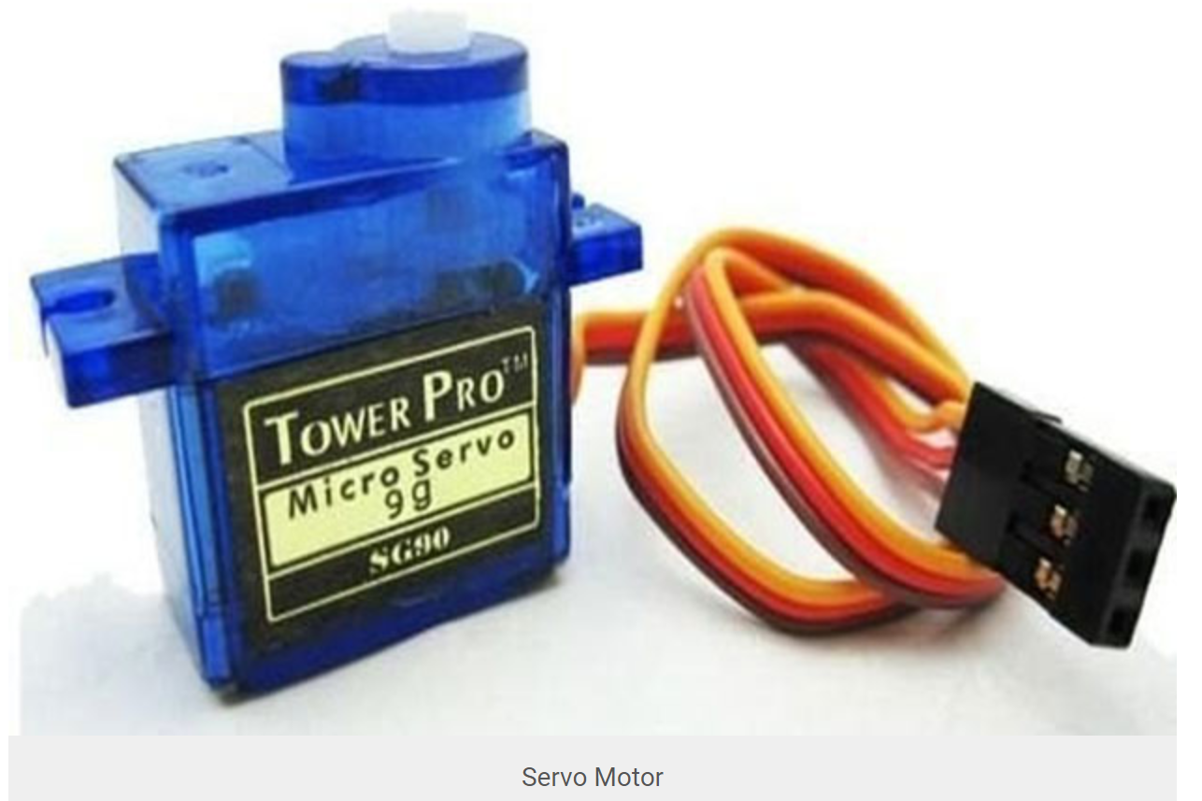

Figure 2.4.4: Servo Motor

A servo motor as shown in Figure 2.4.4, is an electrical device which can push or rotate an object with great precision. If you want to rotate and object at some specific angles or distance, then you use a servo motor. It is just made up of a simple motor which runs through a servo mechanism. If the motor is DC powered then it is called DC servo motor, and if it is AC powered motor then it is called AC servo motor. We can get a very high torque servo motor in small and lightweight packages. Due to these features they are being used in many applications like toy cars, RC helicopters and planes, Robotics, Machine etc.

All motors have three wires coming out of them. Out of which two will be used for Supply (positive and negative) and one will be used for the signal that is to be sent from the MCU.

Servo motor is controlled by PWM (Pulse width Modulation) which is provided by the control wires. There is a minimum pulse, a maximum pulse and a repetition rate. Servo motor can turn 90 degrees from either direction from its neutral position. The servo motor expects to see a pulse every 20 milliseconds (ms) and the length of the pulse will determine how far the motor turns. For example, a 1.5ms pulse will make the motor turn to the 90° position, such as if the pulse is shorter than 1.5ms shaft moves to 0° and if it is longer than 1.5ms then it will turn the servo to 180°.

Servo motor works on PWM (Pulse width modulation) principle, meaning its angle of rotation is controlled by the duration of applied pulse to its Control PIN. Basically, a servo motor is made up of a DC motor which is controlled by a variable resistor (potentiometer) and some gears. High speed force of the DC motor is converted into torque by Gears. We know that WORK= FORCE X DISTANCE, in DC motor Force is less and distance (speed) is high and in Servo, force is High and distance is less. Potentiometer is connected to the output shaft of the Servo, to calculate the angle and stop the DC motor on the required angle.

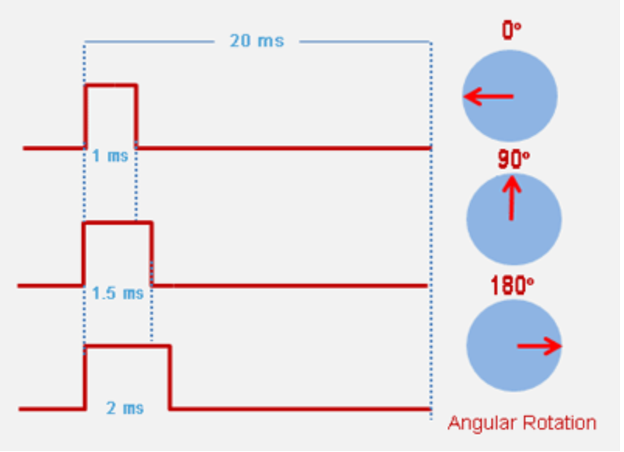

Figure 2.4.5: Rotation mechanics of Servo Motor

Servo motor can be rotated from 0 to 180 degrees, but it can go up to 210 degrees, depending on the manufacturing. This degree of rotation can be controlled by applying the Electrical Pulse of proper width, to its Control pin as shown in Figure 2.4.5. Servo checks the pulse in every 20 milliseconds. Pulse of 1 ms (1 millisecond) width can rotate servo to 0 degree, 1.5ms can rotate to 90 degree (neutral position) and 2 ms pulse can rotate it to 180 degree.

**2.5 SOFTWARE ANALYSIS**

* + **Tinkercad**: Tinkercad is a free, online 3D modelling, Circuit Designing program that runs in a web browser, known for its simplicity and ease of use.
  + **Python:** Python is an interpreted, high-level and general-purpose programming language. The project’s face mask detection program was done using this programme.
  + **Arduino IDE:** The Arduino Integrated Development Environment is a cross-platform application that is written in functions from C and C++. It is used to write and upload programs to Arduino compatible boards, but also, with the help of third-party cores, other vendor development boards. It was used to control the gate’s (Servo Motor) movement when the right condition was met.

**CHAPTER 3**

**SOFTWARE IMPLEMENTATION**

**3.1 SOFTWARE CODING**

**3.1.1 MASK DETECTION**

We have built a CNN model that detects the presence of face masks in people from a webcam using Keras running in a TensorFlow background, OpenCV, and MobileNet V2 architecture[1]. Later the following code was used to detect the mask.

The following code has been implemented Python for mask detection:

from tensorflow.keras.applications.mobilenet_v2 import preprocess_input

from tensorflow.keras.preprocessing.image import img_to_array

from tensorflow.keras.models import load_model

from imutils.video import VideoStream

import numpy as np

import imutils

import time

import cv2

import os

import serial

arduinoData=serial.Serial('com4',115200)

def detect_and_predict_mask(frame, faceNet, maskNet):

(h, w) = frame.shape[:2]

blob = cv2.dnn.blobFromImage(frame, 1.0, (224, 224),

(104.0, 177.0, 123.0))

# pass the blob through the network and obtain the face detections

faceNet.setInput(blob)

detections = faceNet.forward()

print(detections.shape)

# initialize our list of faces, their corresponding locations,

# and the list of predictions from our face mask network

faces = []

locs = []

preds = []

# loop over the detections

for i in range(0, detections.shape[2]):

confidence = detections[0, 0, i, 2]

if confidence > 0.5:

box = detections[0, 0, i, 3:7] * np.array([w, h, w, h])

(startX, startY, endX, endY) = box.astype("int")

(startX, startY) = (max(0, startX), max(0, startY))

(endX, endY) = (min(w - 1, endX), min(h - 1, endY))

face = frame[startY:endY, startX:endX]

face = cv2.cvtColor(face, cv2.COLOR_BGR2RGB)

face = cv2.resize(face, (224, 224))

face = img_to_array(face)

face = preprocess_input(face)

faces.append(face)

locs.append((startX, startY, endX, endY))

if len(faces) > 0:

faces = np.array(faces, dtype="float32")

preds = maskNet.predict(faces, batch_size=32)

print(preds)

return (locs, preds)

prototxtPath = r"face_detector\deploy.prototxt"

weightsPath = r"face_detector\res10_300x300_ssd_iter_140000.caffemodel"

faceNet = cv2.dnn.readNet(prototxtPath, weightsPath)

maskNet = load_model("mask_detector.model")

print("[INFO] starting video stream...")

vs = VideoStream(src=0).start()

while True:

frame = vs.read()

frame = imutils.resize(frame, width=400)

(locs, preds) = detect_and_predict_mask(frame, faceNet, maskNet)

for (box, pred) in zip(locs, preds):

(startX, startY, endX, endY) = box

(mask, withoutMask) = pred

label = "Mask" if mask > withoutMask else "No Mask"

color = (0, 255, 0) if label == "Mask" else (0, 0, 255)

label = "{}: {:.2f}%".format(label, max(mask, withoutMask) * 100)

if mask > withoutMask:

arduinoData.write(b'1')

elif (mask < withoutMask):

arduinoData.write(b'0')

t=0

while(t<2000):

if(t%10==0):

print(t)

t+=1

print("done")

cv2.putText(frame, label, (startX, startY - 10),

cv2.FONT_HERSHEY_SIMPLEX, 0.45, color, 2)

cv2.rectangle(frame, (startX, startY), (endX, endY), color, 2)

cv2.imshow("Frame", frame)

key = cv2.waitKey(1) & 0xFF

if key == ord("q"):

break

cv2.destroyAllWindows()

vs.stop()

**3.1.2 CONTROLLER PROGRAMMING**

The following code has been implemented with the use of Tinker CAD software for programming the controller[4].

**Arduino Code:**

#include <LiquidCrystal.h>

/* Create object named lcd of the class LiquidCrystal */

//LiquidCrystal lcd(13, 12, 11, 10, 9, 8, 7, 6, 5, 4, 3); /* For 8-bit mode */

LiquidCrystal lcd(13, 12, 11, 6, 5, 4, 3); /* For 4-bit mode */

unsigned char Character1[8] = { 0x04, 0x1F, 0x11, 0x11, 0x1F, 0x1F, 0x1F, 0x1F }; /* Custom Character 1 */

unsigned char Character2[8] = { 0x01, 0x03, 0x07, 0x1F, 0x1F, 0x07, 0x03, 0x01 }; /* Custom Character 2 */

const int lm35_pin = A1;

char serialData;

int pin=9;

int servoPin = 9;

Servo servo;

void setup() {

pinMode(pin,OUTPUT);

lcd.begin(16,2); /* Initialize 16x2 LCD */

lcd.clear(); /* Clear the LCD */

lcd.createChar(0, Character1); /* Generate custom character */

lcd.createChar(1, Character2);

servo.attach(servoPin);

}

void loop() {

int temp_adc_val;

float temp_val;

temp_adc_val = analogRead(lm35_pin); /* Read Temperature */

temp_val = (temp_adc_val * 4.88); /* Convert adc value to equivalent voltage */

temp_val = (temp_val/10)+85;

lcd.setCursor(0,0); /* Set cursor to column 0 row 0 */

lcd.print("Temprature is:");

lcd.print(temp_val); /* Print data on display */

delay(1000);

lcd.setCursor(0,1);

lcd.write(byte(0)); /* Write a character to display */

lcd.write(1);

if(Serial.available()>0)

{serialData=Serial.read();

Serial.print(serialData);}

if(serialData=='1'){

digitalWrite(pin,HIGH);

if(temp_val<138)

{

digitalWrite(pin,HIGH);

servo.write(90);

delay(1000);

servo.write(0);

delay(1000);

}

delay(1000);

}

else if(serialData=='0'){

digitalWrite(pin,LOW);

servo.write(0);

}

}

**3.2 WORKING OF FACE MASK AND TEMPERATURE DETECTION**

* We have built a CNN model that detects the presence of face masks in people from a webcam using Keras running in a TensorFlow background, OpenCV, and MobileNet V2 architecture[5].
* The data set used to build the face mask classifier comprises two labels with_mask which comprises 481 images, and without_mask which comprises 480 images[6].
* Image augmentation is done so as to expand the training set. After augmentation, the data set is split into 80% training and 20% testing in order to avoid overfitting
* MobileNetV2 Convolution neural network is used as a feature extractor to train the data set and softmax layer is used to make decisions. The trained model is then validated on the test data set using various metrics such as accuracy, precision and recall[7].
* Next step is deployment of the face mask classifier model. In order to do that we need to extract the Region of Interest (RoI) In our face of people.
* Face detection is done using Haar cascade Classifier which is trained using a lot of positive images (images of faces) and negative images (images without faces)[5][8].
* Our assumption ‘0’ indicates that the person is not wearing a mask and binary digit ‘1’ indicates he is wearing a mask; these values are sent to the arduino via pyserial.
* The temperature is measured using the contactless temperature sensor and displayed in LCD.
* If the person is wearing the mask and temperature value is less than 100.4 Servo rotates by an angle of 180 degree else it LED glows and Servo motor does not rotate.

**3.3 SIMULATION SCREENSHOTS**

The system has been simulated using Tinker CAD software as shown in Figure 3.3.1.

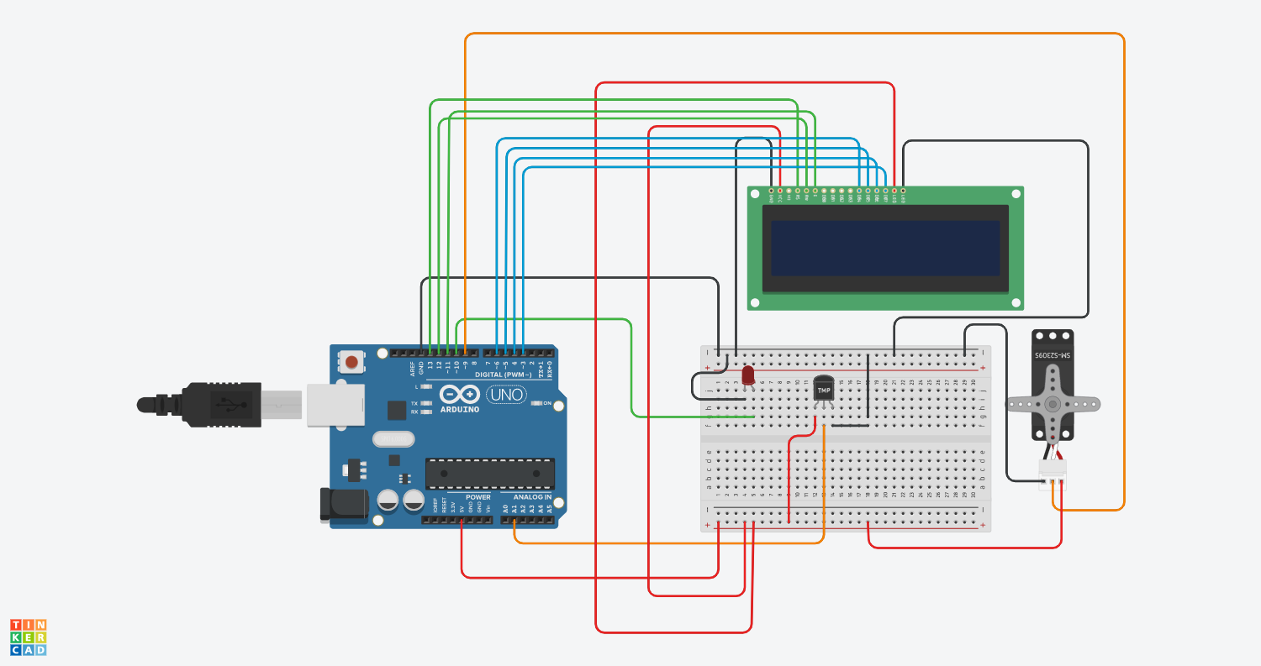Figure 3.3.1 Screenshot of the simulation in Tinkercad

**3.4 EXPERIMENTAL RESULTS AND IMAGES**

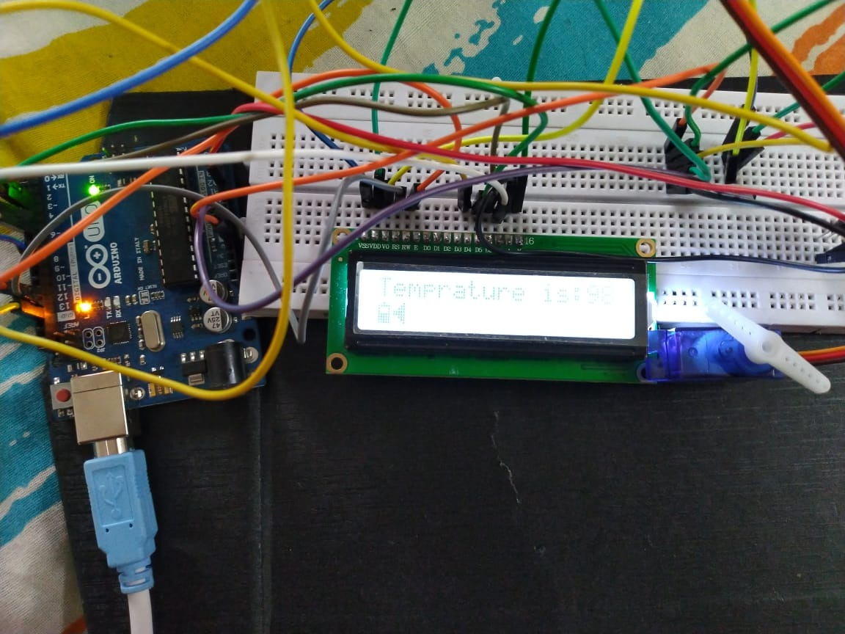

Figure 3.4.1: Hardware implementations

The Figure 3.4.1 shows the hardware that was implemented to construct the project.

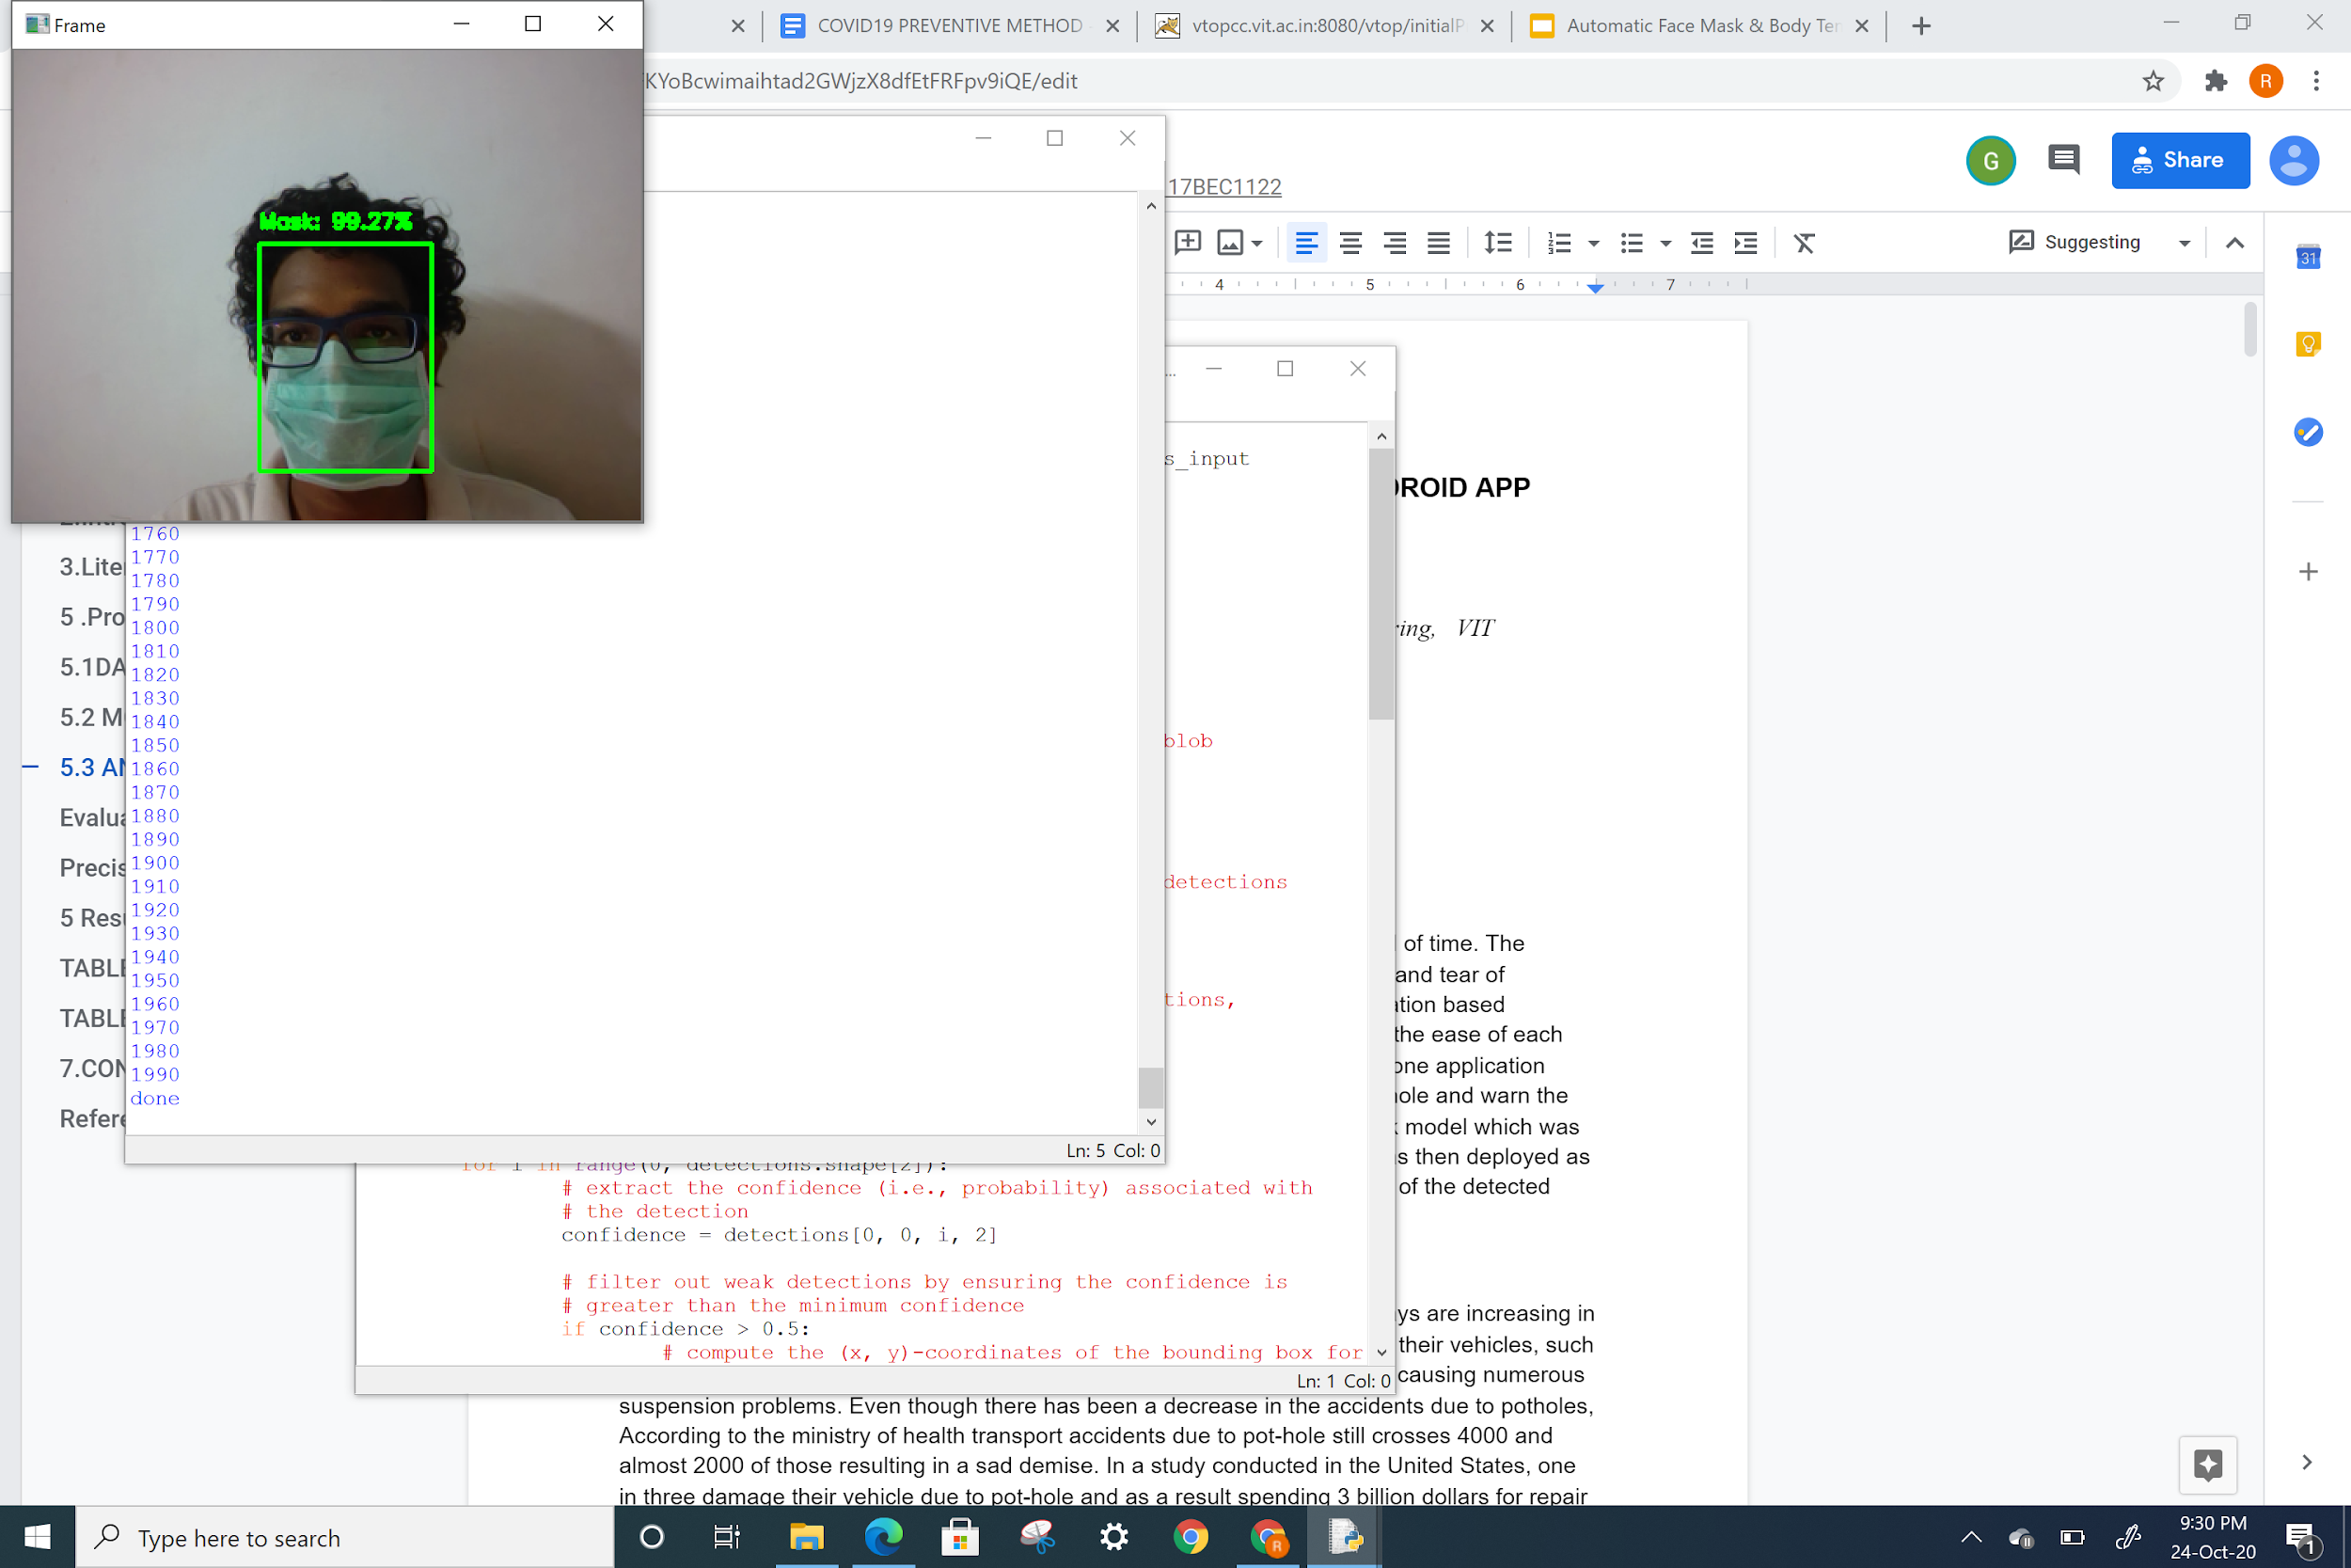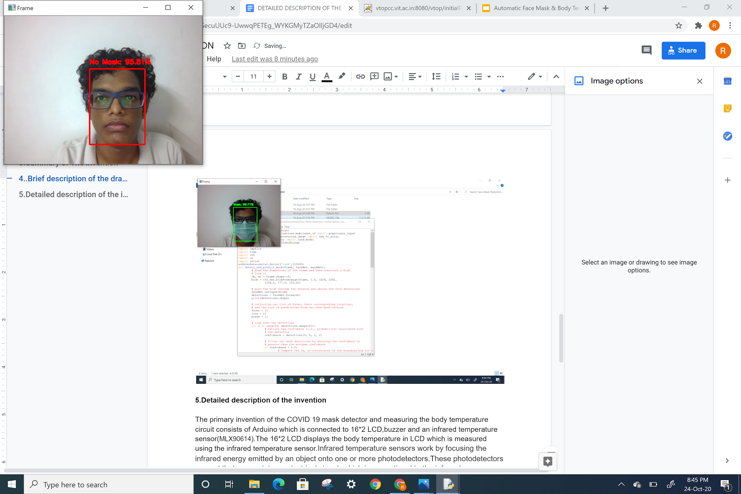

Figure 3.4.2: Mask detection done using a webcam.

Figure 3.4.2 shows the results with both Mask ON and Mask OFF condition.

**CHAPTER 4**

**CONCLUSION AND FUTURE WORK**

**4.1 CONCLUSION**

* We have finally found out the persons wearing face mask and not wearing face mask.
* The body temperature was measured using contactless sensor (MLX90614ESF) and displayed on the 16*2 LCD screen.
* Servo motor acted as a gate and if the person was wearing a mask and his/her body temperature was less than 100.4 ⁰F, then the servo motor rotated by an angle of 180⁰.
* If the person is not wearing mask or his/her body temperature is greater than 100.4 ⁰F, an LED will glow indicating that the person cannot be allowed inside and there will be no rotation in the motor (gate closed).

4.2 **FUTURE WORK**

* Addition of automatic hand sanitizer dispenser to our proposed model.
* Developing face mask detection mobile application.
* Developing a model that recognises face while wearing a mask for authorized entry purposes.
* Detecting temperature using thermal imaging techniques.

**CHAPTER 5**

**REFERENCES**

1. <https://www.pyimagesearch.com/2020/05/04/covid-19-face-mask-detector-with-opencv-keras-tensorflow-and-deep-learning/>

2. <https://www.arduino.cc/en/Tutorial/LibraryExamples/HelloWorld>

3. <https://tryolabs.com/blog/2020/07/09/face-mask-detection-in-street-camera-video-streams-using-ai-behind-the-curtain/>

4. <https://www.theengineeringprojects.com/2018/06/introduction-to-arduino-uno.html>

5. Porter, Robert Mark Stefan, and Ratna Rambaruth. "Face detection." U.S. Patent No. 7,336,830. 26 Feb. 2008.

6.MohamedLoey, GunasekaranManogaran, MohamedHamedN. Taha, NourEldeenM. Khalifa "A hybrid deep transfer learning model with machine learning methods for face mask detection in the era of the COVID-19 pandemic." Measurement 167 (2020): 108288.

7. G. Jignesh Chowdary, Narinder Singh Punn, Sanjay Kumar Sonbhadra, and Sonali Agarwal. "Face Mask Detection using Transfer Learning of InceptionV3." arXiv preprint arXiv:2009.08369 (2020).

8. Lin, K., Zhao, H., Lv, J., Zhan, J., Liu, X., Chen, R., ... & Huang, Z. (2019, July). Face detection and segmentation with generalized intersection over union based on mask R-CNN. In International Conference on Brain Inspired Cognitive Systems (pp. 106-116). Springer, Cham.